TABLE OF CONTENTS PAGE
PART 1 – SYSTEM COMPONENTS
A. Source and wells Statistics . . . 5
B. Treatment Plant . . . . . 5
C. Metering . . . . . .5
D. Chemical Storage and Metering . . 5
E. Aeration . . . . . .5
F. Settling . . . . . . 6
G. Filtration . . . . . .6
H. High Service Pump . . . . 6
I. Finished Water Storage . . . 6
J. Personnel . . . . . .6
K. System Records . . . . . 6
L Indirect Components, Utilities . . 7
PART 2 – EMERGENCY PLANS
I. Short-term Power Failure . . . 7
II. Flood . . . . . . 8
III. Tornado . . . . . .9
IV. Chemical/Bacteriological Contamination 10
V. Main Break in Plant . . . . 12
VI. Plant Component Failure . . . 14
VII. Extended Power Failure . . . 15
VIII. Break in Raw Water Line . . . 16
IX. Distribution System Main Break . . 17
X. Vandalism . . . . . .21
XI. Loss of Critical Pump System . . 22
XII. Chlorine Spill . . . . . 24
XIII. Intentional Chemical/Bacteriological Contamination
XIV. Storage Tank Rupture . . . .
XV. Operator Absence . . . .
PART 3 – PERSONNEL & EMERGENCY PHONE NUMBER
EMERGENCY FUNDS . . . .
PART 4 – ALTERNATIVE SOURCES . .
PART 5 - USERS HAVING CRITICAL NEED
PART 6 - METHODS OF NOTIFICATION .
Notice of Water Emergency Press Release
Disinfection
ADDENDUM: Maps, annual planning and review, sample forms

AMESVILLE WATER SYSTEM
CONTINGENCY PLAN
The Contingency Plan shall be revised and updated as necessary but shall be at least one annually.
Copies of the Contingency Plan are maintained at:
1. Village Wastewater Treatment Works
2. Village Water Treatment Works
3. Village Hall
4. Village Fire House
5. Athens County Emergency Management Agency
6. Ohio Environmental Protection Agency
Date Revised Revised by Remarks
Nov. 2018 Gordon Armstrong Review

Part 1 – SYSTEM COMPONENTS
A. SOURCE
The water supply for the Amesville water system consists of a pair two operable wells, (6, and 7) located adjacent to Federal Creek in a single well field.
WELL STATISTICS
Well Install year Depth Aquifer Depth GPM/TDH GPM GPM
capacity actual
6 ~1987 38’ 12’ ~24
7 1987 38’ 10’ 27.5
B. TREATMENT PLANT
The treatment plant receives raw water from the operable well(s).
Raw water is chlorinated, for disinfection and oxidation. Currently, the aerator is out of service. The chlorinated water is allowed to detent and settle in a series of two 1100-gallon polyethylene vertical tanks. The treated water is evacuated from detention tanks via a ¾ hp motor/pump, and delivered through pressure filter. Once through the filter, filtered water is supplied to the village’s grid supply system, which the storage tank “floats” on.
The high service pump is 3 phase 240 volts.
Well pumps are 220v single phase.
C. METERING
Filtered water effluent is metered, on a 2” line.
D. CHEMICAL STORAGE AND METERING
Sodium Hypochlorite 12.5% is purchased in carboys (15 gallons). A one-month supply, (30 gallon), is normally maintained. The “hypo” is diluted to 1:4 dilution, or 1 gallon’s hypo with 3 gallons distilled water in a day tank with built-in secondary containment fitted with a metering pump. Two and a half day of treatment-ready chemical can be produced at a time.
E. AERATION
The roof top coke tray aeration was removed as of 6/2016. Raw water is treated with an elevated rate of hypochlorite to facilitate oxidation of iron and manganese.

F. SETTLING
Two 1,100-gallon tanks, each 64” in diameter and 87” tall, plumbed in series, and coupled by 2” flex hose provide detention and settling iron, (Fe), and manganese, (Mn), particles. These tanks are directly below the aerator. The settling process allows some of Fe and Mn to precipitate, which reduces the solids loading on the sand filter.
G. FILTERATION
A single 48” by 56” (sidewall) pressure filter (sand, gravel, anthracite) trap particle not settled in detention tanks. The system’s storage head provides water to rinse, (backwash), the filtered particles from the filter. The filter has 12.56 ft² of surface area.
H. HIGH SERVICE PUMP
There are two high service pumps available to provide pressure
I. STORAGE
The system has a single 100,000-gallon storage tank. Usable water is empty at 86.5 psi at the WTP. The altitude valve and telemetry system are abandoned, and electrical service removed.
J. PERSONNEL
Office: 1 Mayor 1 Fiscal officer 1 Billing clerk Water system: 1 Superintendent 1 Assistant Operator
K. SYSTEM RECORDS
Plant logs, Safety Data Sheets, operation and maintenance manuals are kept at the water plant. All other documents are housed at the village office.
L. INDIRECT COMPONENTS
UTILITIES
1. POWER. Provided by American Electric Power Ohio.
2. PROPANE. Rutland Gas

SUPPLIES AND MATERIALS
Liquid 12.5% Sodium Hypochlorite is stored at the water treatment plant. A month supply is maintained. Water pipe repair clamps and pipe scraper are housed at the village storage barn.
PART 2 – EMERGENCY PLAN
I. SHORT – TERM POWER FAILURE (2 HOURS OR LESS)
A. SOURCE
All well pumps would be off and no raw water would be pumped to the Treatment plant.
B. TREATMENT
There would be no treatment as there is no emergency power source at the plant. The Water Superintendent or Mayor should be notified of power failure. Power should be disabled to equipment until service is restored. The power supplier should be contacted to determine the length of outage. When power is restored, all equipment can be restarted, and plant placed back into normal operation mode. The plant should be operated until storage tank produces pressure above 76.5 psi at plant.
C. TRANSMISSION AND DISTRIBUTION
While power is off, no water can be pumped into the system from the treatment plant.
D. STORAGE
Total storage in the village is 100,000 gallons this is about a 5 days’ worth of usage. Generally, the storage tank is kept roughly half-full. Normal storage yields two to three days of service. Thus, short-term power outage should not present any problem.
E. PERSONNEL
Plant operator(s) will report as normally scheduled to restore normal operation when power service is restored.
F. UTILITIES
Call power company (1-800-672-2231) to determine if they have a problem and to find out how long power is expected to be out of service. If the problem is in the plant system, an electrical contractor should be called to make needed repairs.
II. FLOOD
A. SOURCE
The wells are the most vulnerable component of the water system during flooding. The effects can range from no problem to complete loss of raw water supply. Monitor flood water levels; when water covers area around any of the wells, shut the wells off to prevent possible contamination. The top of the well casing and is above the 100-year flood level on all wells.
After floodwaters have receded and pumping is resumed, the chlorine feed rate should be to an increased to produce plant effluent with a free chlorine residual above 2.00 milligram per liter (mg/L). Also, the well water should be checked for turbidity. If power transmission pole(s) is damaged or knocked down by large floating debris or ice causing power loss, call Power Company or electrical contractor to disconnect power. Should a well or wells become contaminated by flood water, they have to be treated by AWWA standards. Then, surge the well by manually starting and stopping the pump several times to mix the chlorine and water in the well. Well must reach 100ppm and remain at least 50 ppm after 8 hours. The well should set for 24 hours, then pumped to waste until total chlorine residual is 0.0 mg/L. Take two total coliform sample 30 minutes apart while the well continues to run, and submit them for analysis. If the total coliform test is positive, the well should be treated again.
B. TREATMENT
The treatment plant is susceptible to flooding, as are wells, and surrounding areas.
The plant may have to be accessed on foot, or by boat. Additional analysis for bacteria and turbidity should be made on both raw and finished water. Free chlorine residual should be maintained above 2.0 mg/L during the flood period. The plant should be operated in such a manner as to keep storage levels in the system at maximum level. Should condition be such that the plant would to be taken out of operation, a level of service would have to be chosen and the public notified to conserve water. As flood water recede, there may be a large demand for water to flush mud from flooded areas. This should not be allowed until the plant is back in full operation and storage tank at least ¾ full.
C. TRANSMISSION AND DISTRIBUTION
If the treatment plant is operational, pumping to the distribution system will be normal. Should residential areas or areas with building be flooded, the water mains serving the flooded areas should be taken out of service by closing the valves on the mains. The reasons for this are to prevent damage to fire hydrants by floating debris. The list of valves begins on page 17.
D. STORAGE
The storage tank is above flooding levels and will not be directly affected by high water.
E. PERSONNEL
All water personnel should be available for possible overtime during and after a flood situation. Extra laboratory analysis and high water use for cleanup and possible decontamination of wells are examples of above normal workloads.
All personnel telephone numbers are listed in Addendum
F. UTILITIES
In case of a power outage call the power company to determine if they have a problem with equipment and to find out how long power is expected to be off. Should the problem be in the plant system or transformer, it should be determined whether the plant is operable. If the problem is in the plant system, an electrical contractor should be called to needed repairs.
Communication generally is conducted via cell phones, but 2-way radios are available at the village office.
G. INDIRECT COMPONENTS
During the period of repressurization of areas, which were flooded, drinking and cooking water may have to be furnished by tank truck until the system is sage for normal use. National or private water haulers would have to be obtained during that period.
H. EMERGENCY EVACUTION
Once it is officially announced that flood waters will reach or exceed the 100-year flood elevation, immediate measures will be taken, all electrical disconnects will be pulled and the plant vacated. An immediate news release will be issued concerning conservation and boiling.
III. TORNADO
- SOURCE
Power lines to the plant could be torn down, along with short-term flooding conditions, making repairs difficult. Refer to Section I of this document
B. TREATMENT
Damage could vary from power loss to direct damage to the treatment plant. In case of power loss, refer to Sections I of the document. Direct damage of the treatment plant could be minor to major. In case of major structural damage, an examination would determine the extent and required repairs. Efforts should be focused on getting the plant operational.
C. TRANSMISSION AND DISTRIBUTION
Damage could be services to buildings suffering damage in the village. Debris could also possibly damage fire hydrants causing leakage. Inspection of damaged areas immediately after a storm should be conducted to determine what action may be required.
The storage tank could be destroyed or damaged by a tornado. Valve is inoperable at storage tank. Damage must be assessed. Maintain VFD service pump at a set pressure.
E. PERSONNEL
Work schedules will have to be established based on the extent of damage and how much can be done by village personnel. Outside contractors will have to be called in if or when their service is needed. Damage to the plant could result in a hypochlorite spill see Section IV of this Water Emergency Contingency Plan for procedures to follow in the event of a chlorine spill.
F. INDIRECT COMPONENTS
The power company would need contacted if power to the system is lost.
Village radio shall serve as communication, as cell service is always sparse.
IV. CHEMICAL/BIOLOGICAL CONTAMINATION
A. SOURCE
The potential for contamination would most likely come by road, specifically, State Route 329.
The Highway Patrol, Sheriff, and local police should be contacted and requested to immediately notify the Village’s water department of any accident involving material spills.
Should a chemical/biological contamination occur, the following step should be taken:
1. Determine the time and location of the contamination.
2. Determine the exact name and volume of the contamination.
3. Call 9-1-1, to contact the village’s Fire department, and Ohio Environmental Protection Agency (OEPA) for assistance at (1-800-282-9378).
4. Determine time that the material will be in the well field area.
5. Determine if the material is harmful or toxic, and if it can be removed by treatment.
6. Set up operation program to stop pumping when the material reaches well field area.
7. Establish sampling and analytical procedures.
8. If material is undesirable in the system, pumping should not be resumed until it has been determined that the material has passed the well field. Both Federal Creek and the well water should be monitored for 6 months or longer after pumping is resumed.
B. TREATMENT
Determine if there are treatment methods which could remove the contaminants. If contamination is bacteriological, chlorine can be used to kill the bacteria.
If the contaminant has entered into the treatment plant and cannot be removed be treatment and is harmful, the plant will have to be drained and flushed.
If the contaminant can be treated, set up temporary treatment until the raw water is back to normal condition.
C. TRANSMISSION AND DISTRIBUTION
If a chemical/biological contamination would get into the system, notify customers. Put out a warning not to drink water. System should be drained and flushed.
If contamination is bacteriological, chlorine can be used to kill the bacteria.
If the water is safe for other purposed, leave the water in the lines. If it is not safe, then flush the water out of the lines.
Make sure the water is at a safe limit before putting the system back into operation.
D. STORAGE
Check for chemical/biological contamination in storage tank and handle as if system is contaminated.
Set up procedure for alternate water supplies by tank truck, etc.
E. PERSONNEL
Plant personnel report as needed to the plant to monitor system and flush wells.
Contact Fire Department to flush the system/storage as needed.
Ohio EPA and outside laboratory for technical assistance and laboratory testing as required.
V. MAIN BREAK IN WATER PLANT
A. SOURCE
A piping breach at the water plant would have no effect on the source wells except that the well pumps would be required to be shut down if the water plant were shut down.
B. STORAGE
1. No effect. Valve at State Route 329 where line crosses Federal Creek would need to be shut.
C. TREATMENT
There are two lines in the plant that could rupture and cause variable extent of damage.
1. With system valve at St. Rt. 329 closed, allow plant to drain via discharge drain.
2. Assess the situation, including whether the piping damage appears to have been intentional. Notify
a. Water supervisor
b. Mayor
c. Fire Department
if intentional
d. Police Department
3. Given damage is taught to be intentional, Set up an Incident Command Post. The Incident Commander will initiate additional notifications as required. Additional notifications may include:
a. Ohio EPA
b. Local FBI field office
c. Athens County Emergency Management Agency
4. Confirm whether equipment damage was intentional or not.
If intentionally damaged:
a. Preserve site for crime scene investigation.
b. Evaluate the need for heightened security at other water system facilities
and initiate require security measures.
5. Call in an electrical contractor to check out any electrical equipment that may be
effected. Have contractor make necessary repairs and remove and dry out motors
which were submerged.
6. Determine extent of damage and get parts for repair of broken pipe.
7. Make time estimate of repairs to piping and equipment to get plant back online.
8. Set up consumer notification of curtailed use of alternate supply if needed.
9. Manage water storage facilities to maintain service to all customers to the maxi-
mum extent possible. Fire protection capabilities/needs should be also assessed.
10. Evaluate the need for alternative sources of water for consumption and fire
protection (ex. hauled water, neighboring water systems). Invoke mutual aid
for fire protection.
11. Upon completion of equipment repairs, disinfect any finished water piping disturbed as a result of this incident.
D. DISTRIBUTION
If the water plant’s function of providing finished water for distribution is compromised for an extended amount of time, the distribution system should be managed to maximize the extent of distribution to the water customers, if possible. If stored water quantities do not allow for water supply to all customers, priority should be given to critical customers (school).
E. PERSONNEL
1. Operators should be onsite making or assisting with repairs.
2. Possible outside mechanical, excavating, and/or electrical contractors.
F. RECORDS
1. Plant drawings

VI. PLANT COMPONENT FAILURE
A. SOURCE
No effect
B. TREATMENT
1. Chemical feed pump.
Chemical feed pumps have redundancy. Each pump feeds a different concentration of Hypochlorite.
If chlorine is not feeding or has not been feeding at the proper dosage, stop pumping immediately. Dose detention tanks with 10ml of full-strength hypochlorite in 100ml distilled water each, one at a time, until free chlorine residual is 6.0-7.0 mg/L. Bring the other feed pump configuration online. Go check system free residual chlorine levels. If lower than 0.20 mg/L, issue a boil order, as needed. A backwash can help bring good chlorine levels back toward the plant, and dispose of under-treated water.
2. Pressure Filter. If the filter fails, contact water supervisor, then the Mayor. Alert the customers and Ohio EPA of an increased iron and manganese content. Valve-in filter bypass. Source a replacement filter (see Starkey soft water Parkersburg).
C. TRANSMISSION AND DISTRIBUTION
1. High service pumps. High service pumps have redundancy. Shut off and valve-out non-functional pump, and valve-in alternative high service pump. Energize alternate pump and resume production. (This assumes the pump circuitry is identical.)
D. STORAGE
Should the level drop drastically while plant is off line, a curtailed use notification to the public may be necessary.
E. PESRSONNEL
Treatment plant personnel should report regularly, as needed, to make or assist in repairs.

VI. EXTENDED POWER FAILURE (MORE THAN 2 HOURS)
A. SOURCE
Same as Section I-A.
B. TREATMENT
Same as Section I-B.
If a loss of power to the water plant appears to be the result of intentional destruction and/or the power outage is expected to be more than a day or two, the following additional guidelines should be followed:
2. Assess the situation, including whether the piping damage appears to have been intentional. Notify
a. Water supervisor
b. Mayor
c. Fire Department
if intentional
d. Police Department
3. Given damage is taught to be intentional, Set up an Incident Command Post. The Incident Commander will initiate additional notifications as required. Additional notifications may include:
a. Ohio EPA
b. Local FBI field office
c. Athens County Emergency Management Agency
4. Confirm whether equipment damage was intentional or not.
If intentionally damaged:
a. Preserve site for crime scene investigation.
b. Evaluate the need for heightened security at other water system facilities
and initiate require security measures.
5. Call in an electrical contractor to check out any electrical equipment that may be
effected. Have contractor make necessary repairs.
6. Set up consumer notification of curtailed use of alternate supply if needed.
7. Manage water storage facilities to maintain service to all customers to the maxi-
mum extent possible. Fire protection capabilities/needs should be also assessed.
8. Evaluate the need for alternative sources of water for consumption and fire
protection (ex. hauled water, neighboring water systems). Invoke mutual aid
for fire protection.
9. Notify water customers of water use restrictions utilizing television/radio broadcasts and/or handbills/flyers.
10. Close communications with the general public should be maintained in the event of a long-term, village-wide water outage.
C. TRANSMISSION AND DISTRIBUTION
Same as Section I-C.
D. STORAGE
The typical storage capacity for the Village is about 2to 3 days of normal use. After an estimated time of power outage is determined, a plan of operation can be established. There should be no problem with an outage of up to 12 hours. Anything greater than 12 hours would require more attentive planning. Storage level can be monitored at the plant without power.
Public notification may be required to establish reduced or regulated use of water during the emergency. Should depressurization occur, an alternate source of water would be needed.
After power restoration and normal pumping is resumed, any area that was depressurized will have to be re-pressurized.
E. PERSONNEL
Treatment plant operators should report normally, as needed, when power is scheduled to be restored. The Mayor or the Operator should call Athens County EMA and Ohio University for access to a three-phase generator capable of maintaining plant operations beyond a 48-hour outage. The Operator or Assistant should maintain observation on the generator and WTP performance to ensure adequate supplies until main electrical power is restored.
F. UTILITIES
For problem, be in the plant system, call an electrical contractor.
VIII. BREAK IN THE RAW WATER LINE
A. SOURCE
There are two wells which can provide raw water to the treatment plant.
Well 6 ~24 gpm – 0.034 MGD
Well 7 27.5gpm - 0.0396 MGD
B. TREATMENT
Treatment would not be affected by the failure of a single raw water line. Failure of both raw water lines at the same time could create a shortage of raw water and the treatment plant could not meet normal demand. Should the repairs take more than 24 hours, steps would have to be taken to curtail water use.
C. TRANSMISSION AND DISTRIBUTION
There would be no effect if normal demand can be met.
D. STORAGE
There would be no effect if normal service can be provided.
E. PERSONNEL
Water personnel should report as scheduled.
F. RECORDS
IX. DISTRIBUTION SYSTEM MAIN BREAK
A. SOURCE
No effect.
B. TREATMENT
In case of a large water loss in the system, treatment production duration may have to be extended to make up for lost water.
C. DISTRIBUTION
1. Determine location of main failure.
2. Call OUPS (811)
3. Determine valve locations to stop flow to break area.
List of valve locations: ‘a’ is 4” cast iron valve ‘b’- ‘l’ are 6” cast iron valves.
a. On SR 329 (Main St.) across Federal Creek and opposite the Treatment Plant on a line parallel to drainage ditch from treatment plant- between guardrail and hardtop
b. On SR 329 (Main St.) in front of the first residence north of county garage- at the edge of hardtop directly in front of residence’s front door.
c. On Harrison t opposite (Kasler’s) Residence at the edge of the South side of the street 6 ft. east of hydrant.
d. On Franklin St. at North East corner of intersection 4 ft. West and 2 ft. South of hydrant.
e. On Franklin St.- Bank corner, at West end of State St. sidewalk in front of Bank.
f. On State St- Bank corner in front of Bank 10 ft. East of Franklin St. in grass between curb and side walk, one foot off curb.
g. On Liberty St. at intersection of State St. at South East corner or intersection in concrete gutter apron.
h. On Liberty St. at intersection Harrison St. on the West edge of Liberty St., 30 ft South of Harrison St.
j. On Harrison St. at corner of Harrison and Franklin St. near valve ‘d’-not exposed.
k. In Franklin St. opposite last house on West side at North end, in middle of street, with square metal cover over. ~10 feet North of hydrant.
l. In Linscott St. new valve ‘k’ in about middle of street with square cover over, ~18 feet North of hydrant.
m. On North side of Linscott St. at North end of Liberty St.-3/4 bleeder valve under meter pit cover.
n. On East side of South Maple St. under steel cover opposite (Clark) residence- a 2” globe valve.
4. Close necessary valves
5. Notify consumers affected.
6. Determine if village staff can perform repair or contractor is needed.
7. Contractor must also call OUPS for their own ticket.
8. Excavate and expose damaged pipe and determine repair materials needed.
9. Obtain repair materials and make repairs.
10. disinfect repaired area of main with chlorination, (for new pipe), flush, and take bacteria sample.
D. STORAGE
Storage tank level will have to be monitored to determine effect of loss due to main break. In case of severe loss and extended downtime for repairs to the system, the localized are may have to be valved off until repairs are made.
E. PERSONNEL
Plant operator should report as needed.
F. RECORDS
The repairers will need drawings of the affected main to locate valves needed to isolate the break. Also, records to determine pipe size and kind in order to obtain repair materials will be needed.
G. INDIRECT COMPONENTS
1. SUPPLIES AND MATERIALS
a. Village inventory
b. Outside supplier
2. VEHICLES AND EQUIPMENT
a. Contractor Equipment
H. COMMUNICATIONS
1. Village radio system and cell phones

I. REPRESSURIZATION OF SYSTEM AND AREAS IN THE SYSTEM
1. REPRESSURIZATION OF SYSTEM
a. Ohio EPA involvement and the approval also of the local health
department.
b. Notify customers that you are starting to pump water and that
the water is to be boiled before use until the system can be tested
and cleared.
c. Start pumping slowly and bring the pressure up very slowly over
a 12 to 24-hour period chlorinate heavily at a Cl₂ feed producing
a free residual 2.0-2.25 milligrams per liter (mg/L) leaving the
plant.
d. When pressure starts up, have Fire department crew open hydrants
in high elevation area and on dead-end lines to release air in the
system.
e. Have customers report any badly discolored or bad smelling water.
Have Fire Department flush these areas.
f. Start sampling water from the plant out through the system for
bacterial contamination.
g. Flush areas showing any bacteria.
h. After all bacteria samples show negative, give the customers
notice to stop boiling drinking water with approval of the Ohio EPA and the local health department.
2. REPRESSURIZATION OF AREA WITH SYSTEM
a. With one or more hydrants open in an area, open the valve to that
area very slowly.
b. Flush hydrants in the area, and notify customers to boil all water
before using.
c. Start sampling water in the area of bacteria.
d. re-flush area if bacteria are present.
e. After all bacteria samples show negative, give the customers notice
to stop boiling water with the approval of the Ohio EPA and local
health department.

X. VANDALISM
A. SOURCE
Areas subject to vandalism:
1. Well heads and pump electrical supply
Reduction or loss of raw water flow will require inspection of the source in use. When damage is determined, the area will have to be isolated and an alternate source used during repairs.
B. TREATMENT
Possible damage could be to electrical transformers, or a window broken to gain entry to the plant.
C. STORAGE
Possible damage to or contamination of storage tanks. The tank would have to be taken out of service until repaired, emptied, flushed, and disinfected.
D. DISTRIBUTION
Fire hydrants being opened and let run or damaged are most susceptible types of vandalism.
E. PERSONNEL
Operators would report as normally.
F. RECORDS
Maps for valve locations and plans for equipment and electrical repairs may be needed.
G. INDIRECT COMPONENTS
1. SUPPLIES AND MATERIALS
a. Village inventory
b. Outside supplier
2. VEHICLES AND EQUIPMENT
a. Contractor Equipment
H. COMMUNICATIONS
1. Village radio system and cell phones
XI. LOSS OF CRITICAL PUMP SYSTEM
A. SOURCE
The plant can meet demand with a single well pump in service. If both wells have failures, the village would normally have 24 hours to rectify the situation before the village would be impacted.
B. TREATMENT
If both high service pumps are lost simultaneously with plant flooding, refer to Section V. of this Water System contingency plan.
In the event of loss of multiple services pumps, initiate response actions as follows:
1. Take immediate measures to ensure the safety of plant personnel. Stop any water from flooding the plant. Shut off power to pumps.
2. Isolate pumps from detention tanks and water distribution system.
3. Make an initial assessment of the situation including whether the equipment damage appears to have been intentional. Initially notify the following
a. Water supervisor
b. Mayor
c. Fire department
4. Setup Command Post. The incident Commander will initiate additional notifications as required. Additional notifications may include:
a. Ohio EPA 1-800-282-9378 Div. of Emergency and Remedial Response
b. Local FBI field office
c. Athens County Emergency Management Agency 740-594-2261 13 Washington, Athens
d. Shut down the remainder of the water plant.
5. Begin pumping out any standing water from the plant.
6. Drain/pump-out any standing water from the plant.
7. Confirm whether equipment damage was done intentionally or not.
If intentional damage:
a. Preserve site for crime scene investigation.
b. Evaluate the need for heightened security
8. Assess damages to the equipment/piping and initiate repairs. Contact outside contractors as required to repair damage. If major repairs or pump replacement is required, contact pump manufacturer for replacement equipment.
9. Notify water customers of water use restrictions if necessary
10. Monitor water storage to maintain service to all customers to the maximum extent possible. Fire protection capabilities and needs should be also assessed.
11. Evaluate the need for alternative sources of water for consumption and fire protection (ex. hauled water etc.). Invoke mutual aid agreements for fire protection.
12. Upon completion of equipment repair, disinfect any finished water piping disturbed as a result of this incident.
C. DISTRIBUTION
The high service pump(s) that facilitate treatment also provide distribution. Refer to section B. of this Section.
D. STORAGE
Finished water storage should provide approximately a two-day supply. This supply will provide an opportunity for the village to initiate incident response outlined above. Storage should be managed to consider fire protection capabilities as well as drinking water services.
E. PERSONNEL
1. WTP personnel should report as needed to make or assist with repairs.
2. Services by the following outside entities may be require:
a. Electrical/mechanical contractors.
b. Equipment suppliers.
XII. CHLORINE SPILL
Procedure for Spills and Leaks

1. Have proper protective equipment available for personnel cleaning up the spill.
2. Contain the spill.
3. Stop the leak while using the proper protective equipment and ventilation.
4. Clean up small spills and leaks immediately using mops, rags, cloth, sawdust or compatible chemical binders such as bentonite, vermiculite or sawdust.
5. Place solvent-laden materials and/or binders in a covered, solvent-resistant metal container.
6. Arrange for proper waste disposal according to applicable laws and regulations.
7. Contact the supervisor, even for small spills and leaks.

Procedure for Large Spills

1. Evacuate the area and call for help immediately.
2. Ventilate the area.
3. Notify the supervisor.
4. Protect yourself. Do not approach the spill area without wearing self-contained, positive-pressure respiratory equipment and suitable protective clothing.
5. Contain the spill.
6. Block floor drains, if present, to prevent the spill from spreading further.
7. Pump spilled solvent into a solvent-resistant container. Close and label the container.
8. Absorb residual spilled solvent with compatible chemical binders such as bentonite, vermiculite or sawdust, and then transfer to a closed container for proper disposal.
9. Spills may have to be reported to the proper authorities if quantities exceed reportable volumes.
After a spill, if the product is reusable, refer to the “Reduce, Reuse, Recycle” section on page 17. The preferred method for disposing of chlorinated solvents and the materials used for cleanup is to send the waste, via an authorized waste hauler, to a licensed reclaimer or to a government approved
incinerator. Perform repairs, and/or take corrective action to prevent recurrence.

XIII. INTENTINAL CHEMICAL/BIOLOGICAL CONTAMINATION OR THREAT THEREOF
This text taken from Wisconsin Public Health Response to sabotage of drinking water.

Drinking-water supplies

The effects of deliberate contamination of water-supply systems are usually limited by dilution, disinfection, and filtration, nonspecific inactivation (hydrolysis, sunlight, and microbial degradation/predation), and the relatively small amount of water to which individuals are usually exposed compared with the total supply. However, with determination and the necessary resources, any part of the system can be penetrated. Outbreaks of cryptosporidiosis, including the large outbreak in Milwaukee, Wisconsin, USA (which was not due to deliberate contamination), demonstrate that water-supply systems are vulnerable (4). Water sources in many parts of the world are generally insecure and therefore more vulnerable to deliberate contamination by chemical or biological agents and the sabotage of equipment and facilities. The level of security at treatment plants varies widely. Deliberate contamination can have not only the direct effects of injury or illness, but also the indirect effects of denial of the supply of drinking water. A successful terrorist attack, whether by contamination or by other forms of sabotage, such as the use of explosives or other physical means, can disrupt the drinking-water supplies of a large city for
months, with serious consequences not only to public health but also to industry and commerce. The sabotage of wastewater-treatment facilities could likewise cause public health problems and similar disruption, particularly downstream, but not of the same magnitude as
those caused by the sabotage of drinking-water treatment plants or distribution systems. Recreational water areas, such as swimming pools, that are not intended for use as sources of drinking-water, are also potential targets for
deliberate contamination, but this will not be considered here. However, much of what is said here about drinking-water systems will also apply to water used for recreation. Drinking-water supply systems consist, in general, of the following components:
– a water source, such as a lake, reservoir, river intake, spring catchment tank, or groundwater borehole;
– a raw water main, which connects the drinking-water source via a pipeline or aqueduct to a water-treatment plant;
– a treatment plant, in which processes such as coagulation, sedimentation, filtration, active carbon treatment, ozonization, and chlorination are carried out;
– a piped distribution system in which drinking-water is transported to end-users or, more commonly, to water tanks or water towers elevated above the end-users; – water tanks and towers, which can provide a steady supply of drinking-water at a more constant pressure; and – a local piped distribution system in which pumped or gravity-fed
water under pressure is provided to residential water tanks and taps or other end-users. A large distribution zone in a well-monitored drinking-water supply system can be relatively difficult to penetrate and contaminate effectively.
There is often only one supplier of drinking-water in each locality, and drinking-water produced in one place is not normally transported to large areas of a country, so that, for each water system, surveillance and security measures can be concentrated on protecting key local installations. Access to points in the system where chemical or biological agents could be introduced in sufficient quantities to cause a large-scale health threat to water ready for end-use is usually limited. In addition, where disinfection with a residual disinfectant is practiced, the range
of chemical and biological agents that a terrorist might use to cause illness or injury is restricted to those that are resistant to disinfection and stable in water for more than a few hours. However, a massive biological contamination might not be neutralized by the residual disinfectant. Nevertheless, there are very few water systems that are not potentially vulnerable to contamination at many points. The distribution system can be the most vulnerable part of the water-supply system, particularly to an experienced water services technician. Commercially available
pumps could be used to inject relatively large quantities of contaminants into the system. It may not be necessary to contaminate a large part of the system in order to cause considerable damage and panic. Most water-supply systems differ in their operational requirements and practices. In areas that rely on the transport of drinking-water, often
over considerable distances, greater security may be required, so that the vulnerability and the actions required to reduce it may vary from system to system. The action needed to reduce the threat of deliberate contamination at specific points in the system will therefore depend on the extent of the vulnerability and the potential impact of contamination at any particular point in the system. The complicity of the staff of the water-supply system, or their coercion, in introducing chemical or biological agents into the water or compromising the water-treatment process, is a possibility that cannot be neglected. Staff should be screened to ensure that their qualifications
and experience are appropriate to the work for which they will be responsible. All staff should be encouraged to report suspicious behavior to the appropriate authorities, but care should be taken to prevent false or unwarranted reports for purposes of harassment.

5.1 Water sources
The possibility of serious human health effects as a result of the contamination of water sources can range from low, as with large reservoirs and rivers, because the water will be diluted and treated before reaching the end-user, to high, as in catchment systems and open shallow wells where treatment is not provided. The security of the source will depend on: – the ease of access to the source and the ability of the terrorist to deliver to it quantities of chemical or biological agents sufficient to cause injury or illness in end-users; – the nature of subsequent water treatment and analysis, and the time available after the detection of a potential problem for a suitable response to be made.
To minimize the risk of unauthorized access to water sources, intakes, inspection points and pump houses, various physical measures, such as fencing and locks, are commonly used. These can be supplemented with on-site security personnel, intrusion detectors, and silent alarms linked to the police and the water-supply company or authority. If
resources permit, remote-controlled television surveillance can also be introduced. Local citizens should be strongly encouraged to report suspicious activities to the proper authorities. Certain water sources, such as rivers, can be vulnerable to large-scale contamination, e.g. from the discharge of large quantities of industrial chemicals and the
sabotage of wastewater-treatment facilities upstream.

5.2 Raw water mains
Raw water mains carrying water to a treatment plant may be vulnerable to contamination. However, their position upstream of the treatment plant in the overall water-supply system means that subsequent inactivation of toxic chemicals and pathogens or their detection is more likely. However, it will be difficult to detect certain types of
chemicals or radioactive materials. In addition, certain microbial agents cannot be detected immediately. Most chemicals and radioactive materials, and certain microbial agents, will not necessarily be removed or inactivated by conventional treatment. Physical security measures, such as those suggested above for water sources, can also be applied in pipelines and pumping stations.

5.3 Treatment plants
Water-treatment plants are of vital importance in water-supply systems. Reducing or eliminating disinfection, in combination with the deliberate introduction of pathogenic organisms, will greatly increase the likelihood
that an infectious dose containing a large number of organisms will be delivered. Some recent outbreaks of waterborne diseases have resulted from the interruption of disinfection operations (5). For the traditional reasons of protecting public health from communicable diseases and industrial chemicals, access to water-treatment plants in
large water-supply systems are usually closely controlled, and on-site laboratory staff analyses samples for a wide range of potential pollutants. Small to medium systems may be more vulnerable. Undetected access to a treatment plant to introduce a contaminating agent should be made more difficult by introducing multi-barrier security and access. These can be supplemented by other measures, such as patrols at irregular intervals, closed-circuit television, and anti-tamper locks and alarms on important equipment and inspection covers. Chlorination is effective against many, but not all, pathogenic biological agents, and can easily be overwhelmed. In addition, the presence of
large chlorine-gas storage tanks, especially in areas with large populations, poses its own terrorist risk. Ozonization is a more expensive form of disinfection, but is generally more effective against contaminating agents, pathogens, and toxins. However, it does not provide any residual protection, such as that provided by chlorination.

5.4 Piped distribution systems
Treated water is usually distributed to end-users through piped distribution systems under pressure and below ground. While the main function of pressurized piped distribution systems is to convey water to people, the pressurized nature of the network can prevent surface water, groundwater, and sewage from coming into contact with treated drinking-water. This makes the deliberate introduction of contaminating agents more difficult, but not impossible. An experienced technician can easily gain access to these systems. Since the water has already gone
through the treatment process, any contamination will most likely remain undetected until it reaches the end-user.

5.5 Water tanks and water towers
In many systems, most end-users do not receive their drinking-water directly from the distribution mains, but from local water tanks and water towers elevated above the end-users. The final distribution to end-users through a local pipe network is often gravity-fed at lower and steadier pressure. The treated water in these tanks and towers is not
under pressure and may therefore be more vulnerable. However, since they are in specific locations, tanks and towers are easier to protect. To improve the security of water tanks and towers, they must be made difficult to access. This can be accomplished by securing the sites with strong fences, erecting multiple barriers to entry, and sealing entry points. These measures can be supplemented by intrusion detectors and silent alarms connected to the police and the water control room. If resources permit, monitoring of water quality parameters, closed circuit
television surveillance, or appropriate on-site security personnel can be used.

5.6 Local piped distribution systems
While systems for piped water pumped or gravity-fed to residential water tanks and taps or other end-users have many points that are vulnerable to deliberate contamination, this is not likely to affect large populations. However, since drinking-water in these distribution systems has already been treated and is not subject to significant dilution, the risk of injury and death among populations exposed to agents introduced at this point in the drinking-water system is high. Certain buildings and houses have their own community piped distribution systems, with
water often received from tanks. This makes intrusion by terrorists much easier than in other parts of the water-supply system. Deliberate
introduction of contamination in distribution systems could be used to target specific buildings or areas or various points in the overall water supply system. Widespread public panic could result from the contamination of even a small part of a distribution system. Both water suppliers and consumers should pay special attention to local distribution systems, and these should also be included in preparedness planning. In local distribution systems, such as those of office and apartment buildings, water lines and meters should be secured, e.g. by means of locked access covers and utility rooms. All suspicious activities, particularly if associated with unusual maintenance or repair work, should be immediately reported to the proper authorities. The separation of individual parts of the water-distribution system improves control and permits the rapid isolation of suspect or contaminated parts of the system. This is a routine design feature in most modern water-distribution systems, and is used in dealing with conventional
problems, such as pipe repair and replacement, and the removal of non-deliberate microbiological contamination.
In particularly sensitive facilities, such as hospitals, public health services, security services, and bottled water and food-processing plants, additional water-treatment processes can be considered.

5.7 Monitoring
Monitoring should be carried out as necessary to give time for an appropriate response. The ability of the quality-control system to detect the presence of contaminating agents will depend on the frequency and range of the analyses undertaken. However, it is impractical to carry out specific analyses for all of the potential chemical and biological agents that could be used. On-line monitors for certain parameters, such as conductivity and pH, may provide some nonspecific indication of a change in water quality and of potential problems. Instrumentation is
available for in-line or rapid general screening of processed water for specific chemical contaminants, and is being developed for biological agents. Bioassays can be a low-technology component of monitoring programs,
and can sometimes give rapid results. A number of nonspecific in vivo and in vitro assays are useful in detecting contamination, particularly by chemicals, and simple immunoassay screening tests for certain bacteria and viruses can be used in response to specific threats. Emergency-response plans must include specific instructions for an
immediate response to abnormal values and for preventing contaminated drinking-water from entering the distribution system, since there will not be time to discuss how to handle a problem once it is detected.
These instructions should include the immediate notification of the appropriate public health authorities. When there is evidence that a drinking-water system has been contaminated by toxic chemicals or pathogenic microbes, the temporary suspension of the water supply may be the only practical way to prevent serious public health problems.
However, this may cause great social inconvenience. The decision-making process on such occasions should be carefully planned and modelled in advance so that such decisions can be reached very quickly.

XIV. ALTERNATE WATER FOR VILLAGE
Primary sources for drinking water equal to one gallon per resident per day shall be provided through the village at the Village Hall and Coonskin Crossing. The Village will maintain 150 gallons of bottled water on site through purchase or donation from: Athens Kroger, Athens Wal-Mart, Trimble Kroger or Chesterhill water system. Additional water will be acquired by village staff (operator, assistant, Mayor). There are no critical users in the system. The Amesville Elementary School would be closed in an emergency via order of the Superintendent.
XV. IN ABSENCE OF OWNER/OPERATOR
The following person(s) are thoroughly familiar with the emergency plan and are authorized to make necessary repairs to the water system in the absence of the owner.
Name | Address | Office Hours | If No Answer, Call
JC Trivett | SR 550, Athens | 24 hours | 740-594-2199
Randall Fields | State Street | 24 hours | 740-448-2321
Javan Thompson | SR 329 | 8:00 to 18:00 | 740-448-1005

The following person(s) are thoroughly familiar with the plan and are available under emergency circumstances:
Name | Address | Office Hours | If No Answer, Call
Gary Goosman | S Franklin | 24 hours | 740-777-4621
Lee Van Dyke | Liberty Street | 24 hours | 740-590-7789

XVI. Notifications
In the event of a de-pressurization, contamination or other system failure the sequence will be as follows:
Operator or Assistant will notify the Mayor (or Council President in the absence of the Mayor) of events and dangers
The Mayor (or Council President) will notify the Ohio EPA via phone, the Athens County EMA via phone, the local health department via phone and convey the nature of the problem and steps planned to address the problem.
The residents shall be notified of the water status via Facebook, email blast, phone calls to those not having access to the prior methods. If needed flyers will be distributed to each household by the Assistant Water Operator or Water Billing Clerk.
Residents shall be informed that drinking water is available at the Coonskin Crossing or Village Hall (give hours of access).
Additional notifications will go to all members of Village Council via email and text.
Barb Klaer: 448-2321 klaerfileds@msn.com
Jayne Darling: 448-3781 jyndarling@gmail.com
Shelley Stark: shelley.stark@gmail.com
Lawrence Kamody: lpkamody@yahoo.com
​Robin Dewey 448-2937
​Gary Richards realtreegary@gmail.com
The process used for authorizing expenditures in the event of an emergency. The amount budgeted for emergencies is $1,200.00 from the General Fund and accessible through the Mayor’s authorized expenditures for conditions as stated above: de-pressurization, contamination by biological or chemical agents or other system failure.

MAPS OF DISTRIBUTION SYSTEM
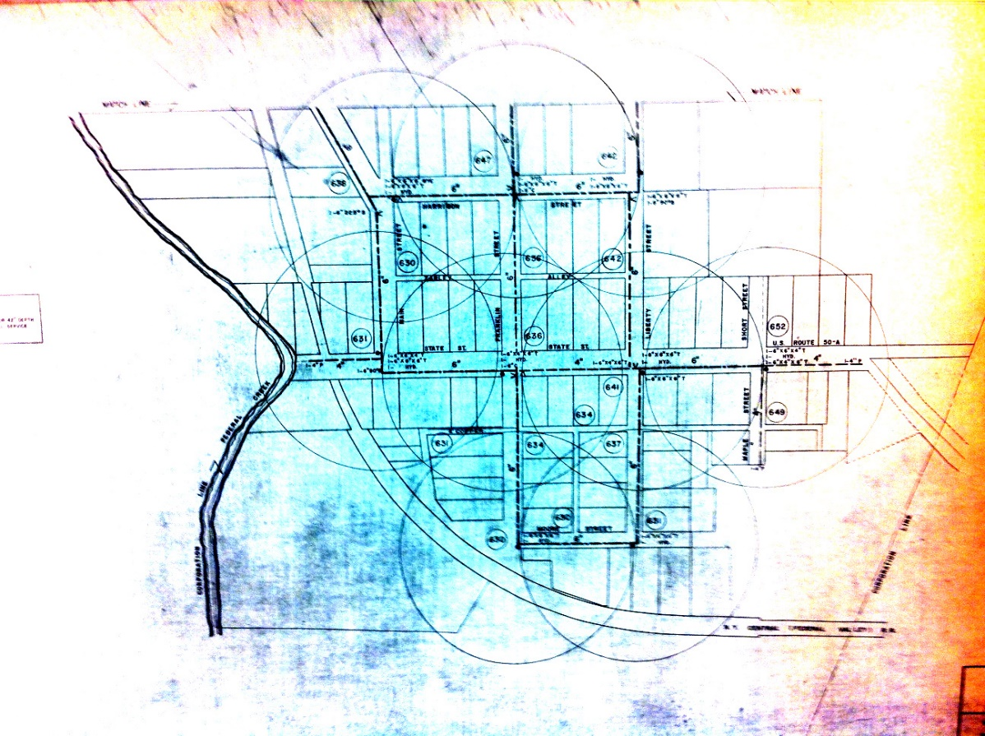
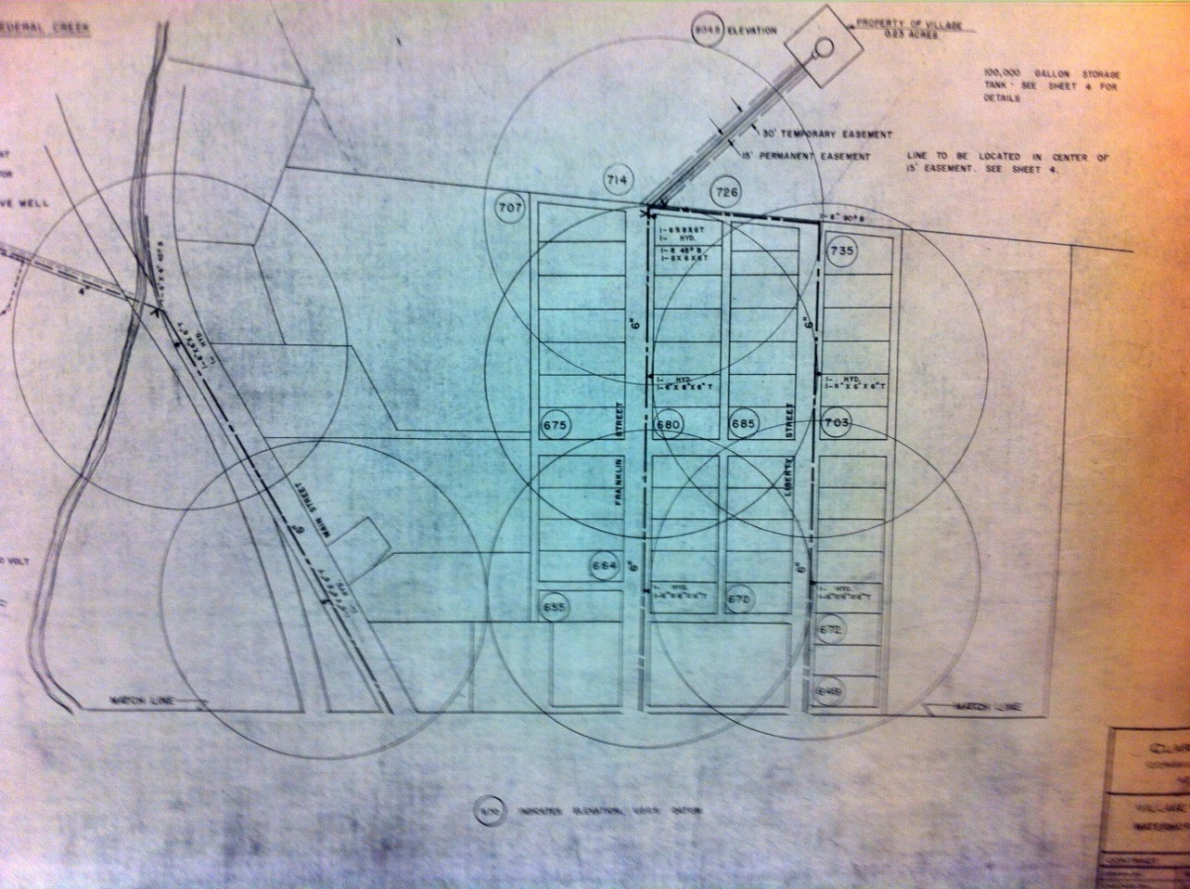
SAMPLING POINT FOR VILLAGE 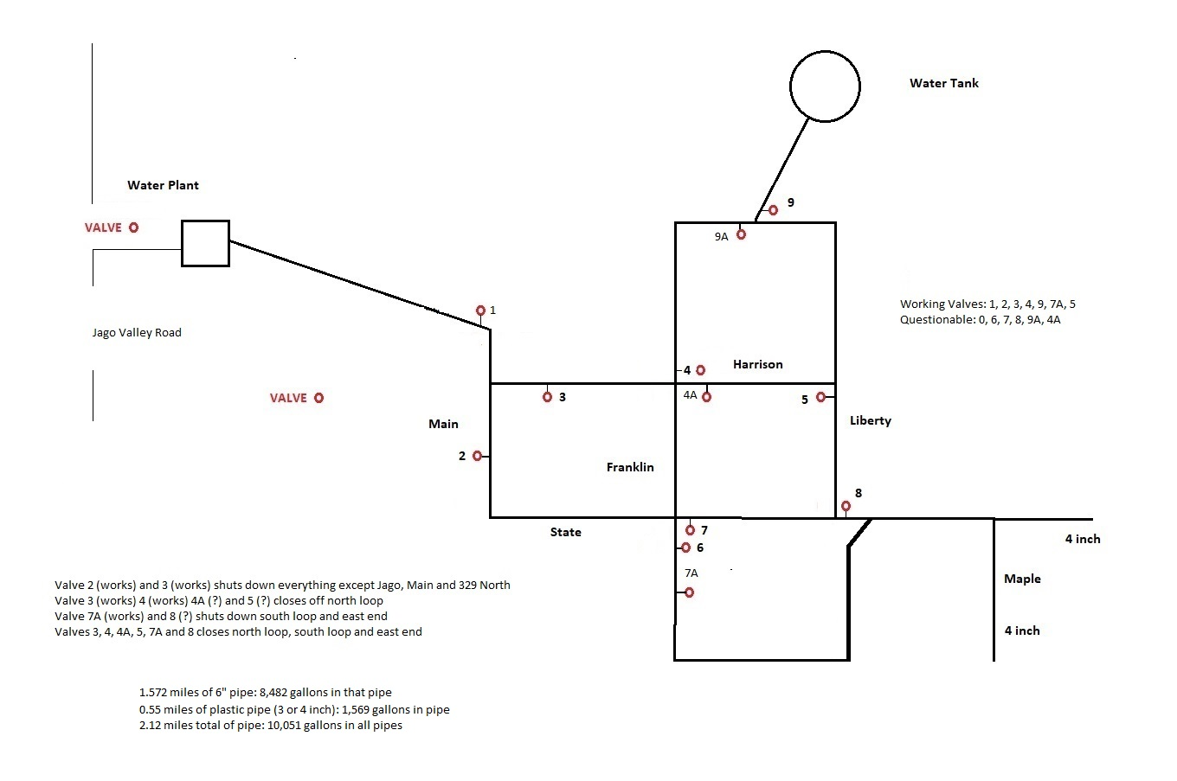
SAMPLING POINT FOR VILLAGE IS VILLAGE HALL (END OF MAPLE STREET). ALTERNATE SITE IS OLD ELEMENTARY SCHOOL (29 NORTH FRANKLIN STREET)

CONTINGENCY PLAN EXERCISES AND RECORDS
The Water System Operator, Water Assistant and Mayor shall at least annually meet to conduct the Contingency Plan Exercise at Village Hall with all residents being notified of the date, time and location of this event. Amesville will follow the requirements (shown below) for carrying out the CPE annually.
OAC Rule 3745-85-01 (E)(1) requires;
At least annually, public water systems shall exercise the responses to one or more of the circumstances identified in the plan. In Amesville the exercise will be discussion-based. Exercises do not need to be conducted outside of normal business operations. Each circumstance identified by the plan shall be included in an exercise at least once every five years. An exercise may include more than one of the circumstances identified by the plan.
OAC Rule 3745-85-01 (E)(2) requires;
Community public water systems shall consult with the county EMA regarding participation in a hazardous spill exercise.
OAC Rule 3745-85-01 (E)(3) requires;
Documentation of exercise participation shall be maintained at the public water system and made available upon request. Documentation shall include information regarding the topic of the exercise, outcomes of the exercise and a discussion of items that went well and improvements that are needed.

MANDATORY WATER CONSERVATION NOTICE

The (AMESVILLE WATER DEPARTMENT) has declared a mandatory water conservation emergency.

The following water uses are considered nonessential and are prohibited during this emergency.

Prohibited Water Uses

- Watering lawns, gardens, landscaped areas, trees, shrubs and outdoor plants.
- Watering golf courses without a valid Drought Emergency Operations Plan.
- Washing paved surfaces, such as streets, sidewalks, driveways, garages, parking areas, tennis courts and patios.
- Operating water fountains, artificial waterfalls and reflecting pools.
- Washing vehicles.
- Serving water in eating places unless specifically requested by the individual.
- Filling and topping off swimming pools.

Please share this information with all the other people who drink this water, especially those who may not have received this notice directly (for example, people in apartments, nursing homes, schools, and businesses). You can do this by posting this notice in a public place or distributing copies by hand or mail.

This notice is being sent to you by

PWSID: Date distributed:

DRINKING WATER WARNING AMESVILLE
DO NOT USE ANY WATER FOR ANY PURPOSE

Due to (Describe problem, for example: a major line break)

People in (Describe the affected area)

Should take the following precautions:
- Do not use any water from this water system for any purpose until further notice.

- Bottled water should be used for drinking, making ice, brushing teeth, washing dishes, and food preparation.

What is being done?
We are investigating and taking the necessary steps to correct the problem as soon as possible. (Describe any additional actions)

For more information, please contact (name of contact) at (phone number) or (mailing address).

PWSID: Date distributed:

DRINKING WATER WARNING AMESVILLE
(AMESVILLE WATER DEPARTMENT) water is contaminated with E. coli
BOIL YOUR WATER BEFORE USING: E. coli bacteria were found in the water supply on (date). These bacteria can make you sick, and are a particular concern for people with weakened immune systems.
What should I do? DO NOT DRINK THE WATER WITHOUT BOILING IT FIRST. Bring all water to a boil, let it boil for at least one minute, and let it cool before using, or use bottled water. Boiled or bottled water should be used for drinking, making ice, brushing teeth, washing dishes, and food preparation until further notice. Boiling kills bacteria and other organisms in the water.
E. coli are bacteria whose presence indicates that the water may be contaminated with human or animal wastes. Human pathogens in these wastes can cause short-term effects, such as diarrhea, cramps, nausea, headaches, or other symptoms. They may pose a greater health risk for infants, young children, the elderly, and people with severely compromised immune systems.
The symptoms above are not caused only by organisms in drinking water. If you experience any of these symptoms and they persist, you may want to seek medical advice. People at increased risk should seek advice about drinking water from their health care providers.
What happened? What is being done?
Bacterial contamination can occur when increased run-off enters the drinking water source (for example, following heavy rains). It also can happen due to a break in the distribution system (pipes) or a failure in the water treatment process. We are investigating and taking the necessary steps to correct the problem as soon as possible.
For more information, please contact (Lee Van Dyke 740-448-2411 or Mayor Goosman 740-777-4621).
General guidelines on ways to lessen the risk of infection by microbes are available from the EPA Safe Drinking Water Hotline at 1(800) 426-4791.
Please share this information with all the other people who drink this water, especially those who may not have received this notice directly (for example, people in apartments, nursing homes, schools and businesses). You can do this by posting this notice in a public place or distributing copies by hand or mail.
PWSID: Date distributed:

APPENDIX I

Collection of Drinking Water Samples
for Total Coliform Bacteria Analysis

The following is the approved procedure for the collection of drinking water samples for analysis of total coliform, as detailed in the methods approved in Ohio Administrative Code rule 3745-81-27. The following procedure should be followed in detail to ensure a valid laboratory analysis.

- Select the sampling tap.
  - A tap, such as faucet or small valve, is preferable. Do not sample from hoses or drinking water fountains.
  - Avoid taps with a leak at the stem or taps with a swivel joint.
  - Aerated or screened nozzles may harbor bacteria. The aerator or screen must be removed before collection of the sample.
  - Use/install a smooth nosed sample tap.

- Place all carbon filters, sediment filters and water softeners on bypass unless operated by the public water system.

- Sanitize the nozzle of the tap with a chlorine solution.
  - Use a 6% sodium hypochlorite solution, such as household liquid bleach. Do not use chlorine solutions with special scents. To prepare a sanitizing solution, add one ounce of bleach to one gallon of water (or 1 tablespoon per half-gallon). Store the mixed solution in a tightly closed screw-capped container. The solution should be discarded and remade 6 months after preparation. Stronger solutions can be used; however, some faucet discoloration may result.
  - Flush the sample tap to waste for 1 minute. Close the valve.
  - Apply the sanitizing solution (prepared in step a.) to the nozzle. This can be accomplished by either using a spray bottle or a plastic bag.
    - Using a spray bottle, saturate the tap opening with sanitizing solution then wait at least 2 minutes before proceeding, or
    - Place a bag over the nozzle and hold the top of the bag tightly on the tap. Alternately squeeze and release the bag to flush the solution in and out of the tap. Do this for 2 minutes. A fresh solution and bag must be used to sanitize each tap.

- Flush the tap. The sample to be collected is intended to be representative of the water in the main. The tap must be opened fully and the water run to waste for at least 3-5 minutes to allow for adequate flushing of the piping between the tap and water main.

- Reduce the flow from the tap to the width of a pencil to allow the sample bottle to be filled without splashing.

- Open the sample bottle.
  - Grasp the bottom of the same bottle.
  - Remove the cap and hold the exterior of the cap between your fingers while filling the sample bottle. Do not lay the cap down. Take care to not touch the mouth of the sample bottle or the inside of the cap with fingers as the sample could become contaminated.
  - The sample bottle must be open only during the collection of the sample.

- Fill the sample bottle.
  - Do not rinse out the sample bottle before collecting the sample. Do not remove any pills, powder, or liquid from the sample bottle. The sample bottle contains a small amount of sodium thiosulfate to neutralize any chlorine in the water.
  - Do not touch the rim or mouth of the sample bottle during collection of the sample.
  - Do not overfill the sample bottle. Fill the sample bottle to within ½” to 1” of the top or to the indicator line on the sample bottle.

- Immediately recap the sample bottle tightly.

- If there is any question as to whether a sample has become contaminated during collection, it must be discarded and a new one collected in a new sample bottle.

- Deliver the sample to the laboratory as soon as possible.

- Samples should be kept cool after collection and during transport to the laboratory. The laboratory must receive the sample so that analysis can be initiated within 30 hours after collection. Allow the laboratory adequate time to analyze the sample. Certified laboratories will not test samples greater than 30 hours old because the results will be invalid.

Additional information
- A bacteriological sample report form is supplied with each sample bottle. The top half of the form is to be filled out in a legible manner using an indelible pen, rubber stamp, or typewriter. Do not use a fountain pen or other pens having water soluble ink.
- Samples must be collected in sample bottles supplied by the certified laboratory.
- Bacteriological sample report forms that have not been properly completed, including the name of the water system, PWS ID#, address, date and time of collection, sample type and location (specific tap) and signature of collector will not be accepted for bacteriological examination.

